

Worksheet-1: C++ Basics

Submitted by – James Limbu

Submitted to - Aashish Acharya

Task 1 : Programming Exercises:[Data types and Conditional Statements]
- Write a program that takes a temperature value from the user. It should then allow the user to choose between Celsius (C) and Fahrenheit (F) for conversion. After the user selection, it should then convert the entered temperature to the chosen scale and display the result.
Use appropriate data types for temperature and handle error like non-numeric input.
Use the following formula for conversion:
F = (C x 9/5) + 32
C = (F - 32) x 5/9
#include<iostream>
using namespace std;
int main()
{
int c,f,option;
while (true)
{
cout<<" ---------------------------------------------- "<<endl;
cout<<" put 0 for converting temperature in fahrenheit "<<endl;
cout<<" ---------------------------------------------- "<<endl;
cout<<" put 1 for converting temperature in celcius "<<endl;
cout<<" ---------------------------------------------- "<<endl;
cout<<" enter the option you want for conversion: ";
cin>>option;
if(option == 0){
cout<<"enter the tempereture value to convert in fahrenheit: ";
cin>>c;
cout<<"degree fahrenheit: "<<(c * 9/5) + 32<<endl;
break;

}
else if (option == 1)
{
cout<<"enter the temperature valoe to convert in celcius: ";
cin>>f;
cout<<"degree celcius: "<<(f - 32) * 5/9<<endl;
break;
}

else{
cout<<" ----------------- "<<endl;
cout<<" enter either 0 or 1"<<endl;
cout<<" ----------------- "<<endl;
}
}
return 0;
}
OutPuts:
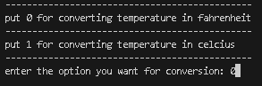
1. For converting temperature in farenheit.
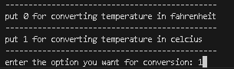
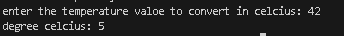
2. For converting temperature in celcus.
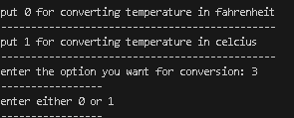
3. If the user selects an alternative option instead of the one given.

2. Write a C++ program to implement a number guessing game with different difficulty levels. Easy difficulty ranges from 1-8, medium from 1-30, hard from 1-50.Then,generate a random number to check if the guess is correct based on the user's selection.
#include <iostream>
#include <cstdlib>
#include <ctime>
using namespace std;
int main(){
int user_number,option,random_number;
while(true){
cout<<" ....................................... "<<endl;
cout<<" Here are your option for guessing game: "<<endl;
cout<<" ---------------------------------------"<<endl;
cout<<" 1. press 0 for easy level (0-8)"<<endl;
cout<<" 2. press 1 for medium level (1-30)"<<endl;
cout<<" 3. press 2 for hard level (1-50)"<<endl;
cout<<" -----------------------------> ";

cin>>option;

if(option==0){
cout<<" enter the number you have in mind: ";
cin>> user_number;
srand(time(nullptr));
int random_number = rand() % 8;
if(random_number== user_number)
{
cout<< "well done! that was quite fun :) ";
}
else{
cout<< "better luck next time T_T "<<endl;
cout<< "the number was: "<< random_number;
}
break;
}
else if(option==1){
cout<<" enter the number you have in mind: ";
cin>> user_number;
srand(time(nullptr));
int random_number = rand() % 30;
if(random_number== user_number)
{
cout<< "well done! that amazing :) ";
}
else{
cout<< "better luck next time T_T "<<endl;
cout<< "the number was: "<< random_number;
}
break;
}
else if(option==2){
cout<<" enter the number you have in mind: ";
cin>> user_number;
srand(time(nullptr));
int random_number = rand() % 50;
if(random_number== user_number)
{
cout<< "well done! that was crazy :) ";
}
else{
cout<< "better luck nest time T_T "<<endl;
cout<< "the number was: "<< random_number;
}
break;
}
else{
cout<<"enter the numbers between those options!!!"<<endl;
}
}

return 0;
}
Outputs:
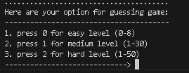
1. Options for user to choose
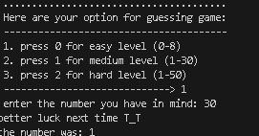
2. When the user chooses option one
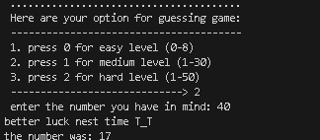
3. When the user chooses option no. 2
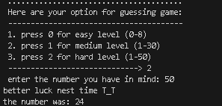
4. When the user chooses option no. 3
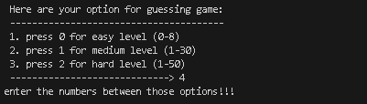
5. when the user chooses outside the given option.

3.Write a program that reads an array of integer numbers from the user and sorts the numbers in the ascending order.
#include <iostream>
#include <algorithm>
using namespace std;

int main() {
const int SIZE = 10;
int a[SIZE];

for (int i = 0; i < SIZE; i++) {
cout << "Enter element " << i << ": ";
cin >> a[i];
}
sort(a, a + SIZE);
cout << "\nSorted array in ascending order:\n";
for (int i = 0; i < SIZE; i++) {
cout << a[i] << " ";
}
cout << endl;

return 0;
}

Output:
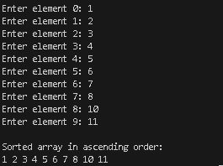

4. Write a program that reads a number from the user and based on the user input, it says what day of the week it is, Sundays being 1 and Saturdays being 7. You system should give appropriate response for invalid input entries.
#include <iostream>
using namespace std;
int main() {
int day;
while (true) {
cout << "Enter day number (1-7, Sunday=1): ";
cin >> day;
if (day == 1) {
cout << "Sunday" << endl;
break;
}
else if (day == 2) {
cout << "Monday" << endl;
break;
}
else if (day == 3) {
cout << "Tuesday" << endl;
break;
}
else if (day == 4) {
cout << "Wednesday" << endl;
break;
}
else if (day == 5) {
cout << "Thursday" << endl;
break;
}
else if (day == 6) {
cout << "Friday" << endl;
break;
}
else if (day == 7) {
cout << "Saturday" << endl;
break;
}
else {
cout << "Invalid day! Please try again." << endl;
}
}
return 0;
}
Outputs:
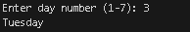
1. if the user inputs between 1-7.
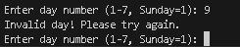
2. if the user inputs outside 1-7.

Task 2: Programming Exercises:[Control Statements]
1. Create a program that takes a positive integer as input and determines whether it's a "bouncy number". A bouncy number is one where the digits neither consistently increase nor consistently decrease when read from left to right. For example:
● 123 is NOT bouncy (digits consistently increase)
● 321 is NOT bouncy (digits consistently decrease)
● 120 is bouncy (neither consistently increasing nor decreasing)
#include <iostream>
using namespace std;

int main() {
int user_number;
cout << "Enter a number (at least 3 digits): ";
cin >> user_number;
if (user_number < 100) {
cout << "Too small - needs 3+ digits";
}
int n = user_number;
bool up = false, down = false;
int last = n % 10;
n = n / 10;
while (n > 0) {
int current = n % 10;
if (current < last) up = true;
if (current > last) down = true;
if (up && down)
break;
last = current;
n = n / 10;
}
if (up && down)
cout << user_number << " is bouncy number!";
else
cout << user_number << " is not bouncy number";
return 0;
}
Outputs:
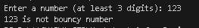
1. if the user inputs non bouncy number.
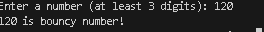
2. if the user inputs bouncy number.

Task 3: Programming Exercises on Arrays
1. Write a program that manages a cinema ticket booking system. The program should display a 5x5 seating arrangement where: [25 marks]
1. Available seats are marked with 'O'
2. Booked seats are marked with 'X'
Program should:
1. Display the current seating arrangement
2. Ask user for row and column number (1-5) for booking
3. Mark that seat as booked ('X')
4. Show updated seating after each booking
5. Display error if user selects already booked seat
6. Display error if user enters invalid row/column numbers
#include <iostream>
using namespace std;

int main() {
const int ROWS = 5;
const int COLS = 5;
char seats[ROWS][COLS];
for (int i = 0; i < ROWS; i++) {
for (int j = 0; j < COLS; j++) {
seats[i][j] = 'O';
}
}
cout << "Welcome to Cinema Ticket Booking System!\n";
while (true) {
cout << "\nCurrent Seating Arrangement:\n";
cout << " 1 2 3 4 5\n";
for (int i = 0; i < ROWS; i++) {
cout << i+1 << " ";
for (int j = 0; j < COLS; j++) {
cout << seats[i][j] << " ";
}
cout << endl;
}
cout << endl;
int row, col;
cout << "Enter row and column (1-5) to book (0 0 to exit): ";
cin >> row >> col;
if (row == 0 && col == 0) {
cout << "Thank you for using our booking system!\n";
break;
}
if (row < 1 || row > ROWS || col < 1 || col > COLS) {
cout << "Invalid seat selection! Please enter numbers between 1-5.\n";
continue;
}
if (seats[row-1][col-1] == 'X') {
cout << "Seat already booked! Please choose another seat.\n";
continue;
}
seats[row-1][col-1] = 'X';
cout << "Seat booked successfully!\n";
}

return 0;
}

Outputs:
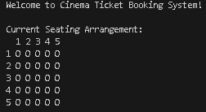
1. user interface of the output
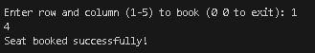
2. when user inputs seat value.
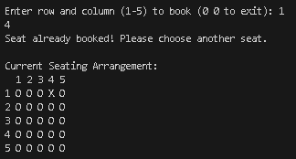
3. when user inputs the seat that is booked.

